**Pizza Sales Report**

Embarking on a journey to uncover the dynamics of our pizza sales business, we recognize the paramount importance of data-driven insights. To navigate the intricate landscape of our performance, we have outlined key performance indicators (KPIs) and chart requirements that will serve as our compass. The KPIs, encompassing Total Revenue, Average Order Value, Total Pizzas Sold, Total Orders, and Average Pizzas Per Order, will be scrutinized to gain a nuanced understanding of our financial and operational benchmarks. Complementing this analysis, we are eager to visualize trends through an array of charts, ranging from the daily and monthly trends of total orders to the distribution of sales across pizza categories and sizes. Furthermore, we seek to unravel the success stories and challenges by spotlighting the top 5 best and least selling pizzas based on revenue, total quantity, and total orders. This holistic approach to data exploration and visualization sets the stage for informed decision-making and strategic advancements in our pizza sales endeavors.

**KPI’s Requirements**

We need to analyze key indicators for our pizza sales data to gain valuable insights to the performance of the business. Please use the following metrics:

**Total Revenue:** Total sum of all pizza orders

**Average Order Value:** The average amount spent per order. Calculated by dividing the total revenue by the total number of orders

**Total Pizzas Sold:** The sum of quantities of all pizzas sold

**Total Orders:** The total number of orders placed

**Average Pizzas Per Order:** The average number of pizzas sold by order. Calculated by dividing the total number of pizzas by the total number of orders

**Charts Requirements**

We would like to visualize various aspects of our pizza sales data to gain insights and understand key trends. We have identified the following requirements for creating charts:

**Daily Trend for Total Orders:** Create a bar chart that displays the daily trend of total orders over a specific time period.

**Monthly Trend for Total Orders:** Create a line chart that illustrates the hourly trend of total orders throughout the day.

**Percentage of Sales by Pizza Category:** Create a pie chart that shows the distribution of sales across different pizza categories.

**Percentage of Sales by Pizza Size:** Generate a pie chart that represents the percentage of sales attributed to different pizza sales.

**Total Pizzas Sold by Pizza Category:** Create a funnel chart that presents the total number of pizzas sold for each pizza category.

**Top 5 Best Sellers by Revenue, Total Quantity and Total Orders:** Create a bar chart highlighting the top 5 best selling pizzas based off of revenue

**Top 5 Least Selling Pizza by Revenue, Total Quantity and Total Orders:** Create a bar chart showcasing the bottom 5 worst selling pizzas based on revenue

**Pizza Sales SQL Queries**

1. **KPI’s**
2. **Total Revenue**

**SELECT** *SUM*(total_price) **AS** Total_Revenue **FROM** pizza_sales

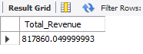

1. **Average Order Value**

**SELECT** (***SUM***(total_price) / **COUNT(*DISTINCT*** order_id)) **AS** Avg_order_Value **FROM** pizza_sales

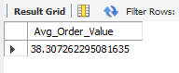

1. **Total Pizza Sold**

**SELECT *SUM*(**quantity**) AS** Total_pizza_sold **FROM** pizza_sales

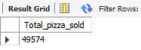

1. **Total Orders**

**SELECT COUNT(DISTINCT** order_id) **AS** Total_Orders **FROM** pizza_sales

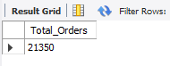

1. **Average Pizzas Per Order**

**SELECT SUM**(quantity) **/ COUNT(DISTINCT** order_id) **AS** Avg_Pizza_Per_Order **FROM** pizza_sales

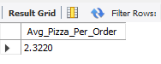

1. **Average Pizzas Per Order(Simplified using CAST function)**

**SELECT CAST(CAST(SUM**(quantity) **AS DECIMAL (10,2)) /**

**CAST(COUNT(DISTINC**T order_id) **AS DECIMAL (10,2)) AS DECIMAL (10,2)) AS** Avg_Pizza_Per_Order **FROM** pizza_sales

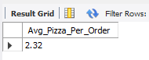

**B. Chart Requirements**

1. **Daily Trend of Total Orders**

**SELECT DATENAME(DW,** order_date**) AS** Order_Day**, COUNT(DISTINCT** order_id**) AS** Total_Orders

**FROM** pizza_sales

**GROUP BY DATENAME(DW,** order_date**)**

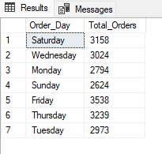

1. **Monthly Trends for Total Orders**

**SELECT DATENAME(Month,** order_date**) AS** Month_Name**, COUNT(DISTINCT** order_id**) AS** Total_Orders

**FROM** pizza_sales

**GROUP BY DATENAME(Month,** order_date**)**

**ORDER BY** Total_Orders **DESC**

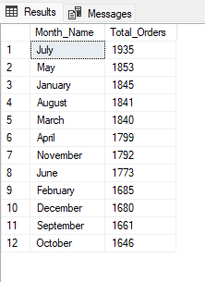

1. **Percentage of Sales by Pizza Category**

**SELECT** pizza_category, **SUM**(total_price) * 100 / (**SELECT SUM**(total_price) **FROM** pizza_sales) **AS** PCT

**FROM** pizza_sales **AS** Total_Sales

**GROUP BY** pizza_category

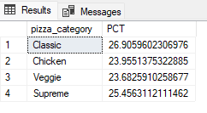

1. **Percentage of Sales by Pizza and Month(Jan-Mar)**

**SELECT** pizza_category**, SUM(**total_price**) AS** Total_Sales**, SUM(**total_price**) * 100 /**

**(SELECT SUM(**total_price**) FROM** pizza_sales **WHERE MONTH(**order_date**) = 1) AS** PCT

**FROM** pizza_sales **AS** Total_Sales

**WHERE MONTH(**order_date**) = 1**

**GROUP BY** pizza_category

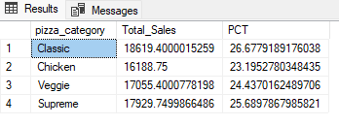

**SELECT** pizza_category**, SUM(**total_price**) AS** Total_Sales**, SUM(**total_price**) * 100 /**

**(SELECT SUM(**total_price**) FROM** pizza_sales **WHERE MONTH(**order_date**) = 2) AS PCT**

**FROM** pizza_sales **AS** Total_Sales

**WHERE MONTH(**order_date**) = 2**

**GROUP BY** pizza_category

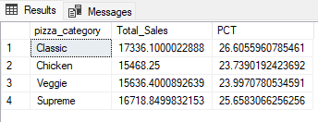

**SELECT** pizza_category**, SUM(**total_price**) AS** Total_Sales**, SUM(**total_price**) * 100 /**

**(SELECT SUM(**total_price**) FROM** pizza_sales **WHERE MONTH(**order_date**) = 3) AS PCT**

**FROM** pizza_sales **AS** Total_Sales

**WHERE MONTH(**order_date**) = 3**

**GROUP BY** pizza_category

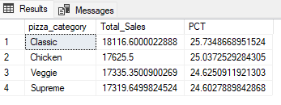

1. **Percentage of Sales by Pizza Size**

**SELECT** pizza_size**, SUM(**total_price**) AS** Total_Sales**, SUM(**total_price**) * 100 /**

**(SELECT SUM(**total_price**) FROM** pizza_sales**) AS** PCT

**FROM** pizza_sales **AS** Total_Sales

**GROUP BY** pizza_size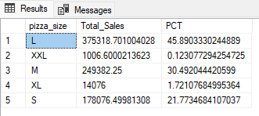

(with CAST function)

**SELECT** pizza_size, **CAST(SUM(**total_price) **AS DECIMAL(10,2)) AS** Total_Sales, **CAST(SUM**(total_price) * 100 /

**(SELECT SUM**(total_price) **FROM** pizza_sales) AS DECIMAL(10,2)) AS PCT

**FROM** pizza_sales

**GROUP BY** pizza_size

**ORDER BY** PCT **DESC**

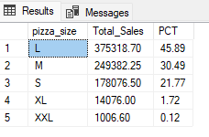

**7. Quarterly Percentage By Pizza Size**

**SELECT** pizza_size**, CAST(SUM(**total_price**) AS DECIMAL(10,2)) AS** Total_Sales**, CAST(SUM(**total_price**) * 100 /**

**(SELECT SUM(**total_price**) FROM pizza_sales WHERE DATEPART**(**quarter,** order_date**)= 1) AS DECIMAL(10,2)) AS PCT**

**FROM** pizza_sales

**WHERE DATEPART(quarter,** order_date**)= 1**

**GROUP BY** pizza_size

**ORDER BY** PCT **DESC**

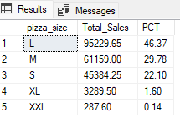

**8. Top 5 Best & Worst Sellers by Revenue, Total Quantity, and Total Orders**

**Top 5 by Revenue**

**SELECT TOP 5** pizza_name**, SUM(**total_price**) AS** Total_Revenue

**FROM** pizza_sales

**Group BY** pizza_name

**ORDER BY** Total_Revenue **DESC**

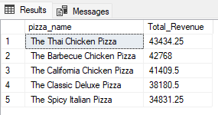

**Bottom 5 Revenue**

**SELECT TOP 5** pizza_name**, SUM(**total_price**) AS** Total_Revenue

**FROM** pizza_sales

**Group BY** pizza_name

**ORDER BY** Total_Revenue **ASC**

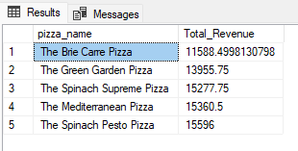

**Top 5 by Quantity**

**SELECT TOP 5** pizza_name**, SUM(**quantity**) AS** Total_Quantity **FROM** pizza_sales

**Group BY** pizza_name

**ORDER BY** Total_Quantity **DESC**

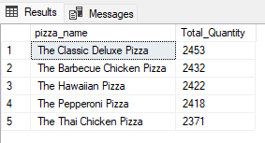

**Bottom 5 Quantity**

**SELECT TOP 5** pizza_name**, SUM(**quantity**) AS** Total_Quantity **FROM** pizza_sales

**Group BY** pizza_name

**ORDER BY** Total_Quantity **ASC**

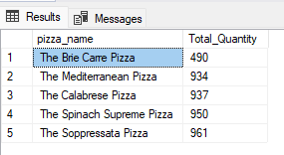

**Top 5 Order Totals**

**SELECT TOP 5** pizza_name**, COUNT(DISTINCT** order_id**) AS** Total_Orders

**FROM** pizza_sales

**Group BY** pizza_name

**ORDER BY** Total_Orders **DESC**

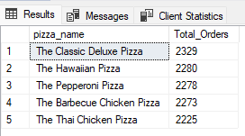

**SELECT TOP 5** pizza_name**, COUNT(DISTINCT** order_id**) AS** Total_Orders

**FROM** pizza_sales

**Group BY** pizza_name

**ORDER BY** Total_Orders **DESC**

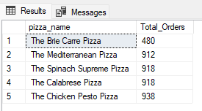

**Monthly Total Pizzas Sold**

**SELECT TOP 5** pizza_name**, SUM(**quantity**) AS** Total_Pizzas_Sold

**FROM** pizza_sales

**WHERE MONTH(**order_date**) = 8**

**Group BY** pizza_name

**ORDER BY SUM(**Quantity**) ASC**

